GitHub repository: <https://github.com/hackerman24816/Intro-to-IT-A1>

GitHub Url: <https://hackerman24816.github.io/Intro-to-IT-A1/>

Personal Information

Name: Vincent Chieu

Student Email: S3977557.student.rmit.edu.au

Student Number: s3977557

Picture: 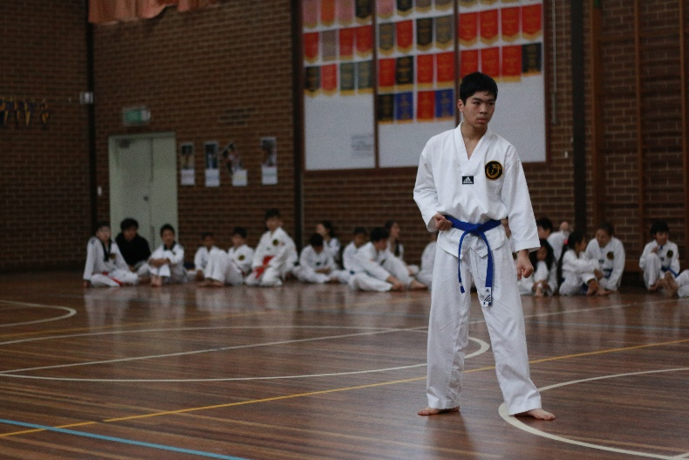

Background Info (paragraphs):

Hi, my name is Vincent and I come from a Chinese/Vietnamese background which is from my mum who is Vietnamese/Chinese/Cambodian and from my father, who is Vietnamese/Chinese. At home I speak fluent Cantonese with my parents and outside I can speak fluent English. For my education I graduated from Salesian college in 2020 and currently I am taking a course in Intro to Programming and Intro to Information Technology. Something interesting about me is that I can play the piano and some hobbies I have is listening to music, gaming and different sports.

IT Interests

* When and why IT:

I didn’t really have a point where I had a spark to pick IT as I have been using it ever since I got my first laptop in grade 6. But the point where I chose IT was when my school had job career/course advice and I hadn’t thought of any career that I wanted to go for, so I picked the one I had the most interest in which was IT.

* Why RMIT?:

I picked RMIT because I wanted to look for higher education to assist me in finding a job that I wanted. After browsing through some universities, I heard that RMIT was a really good university from relatives/friends. They said although the popular unis such as Monash, Melbourne Uni had high success rate, the professors and cohort wasn’t exactly a place where people could communicate well with one another and that RMIT was a better experience for them overall. Therefore, I followed their advice and picked RMIT.

* What I expect to learn:

Coming into RMIT, I thought the course was just going to be about IT systems. After joining this course, I learnt there is much more to this course as it also tries to teach teamwork in the workplace. Now I expect to learn much more than just IT systems. I believe by the end of this course I will learn how to interact with other people better and about how IT systems work.

Ideal Job

* Text

  Description automatically generated with medium confidence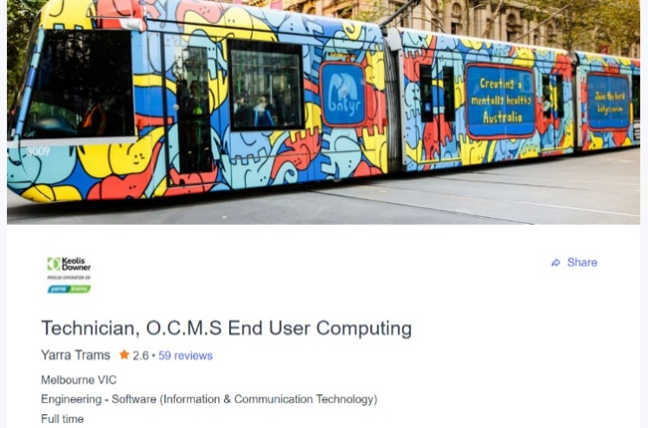Job link (picture):

[https://www.seek.com.au/job/58488475?type=promoted#sol=09bcec532d8e2bcf77f4f6cc89d8180d603067b4](https://www.seek.com.au/job/58488475?type=promoted" \l "sol=09bcec532d8e2bcf77f4f6cc89d8180d603067b4)

* Why this job?

I believe that this job is my ideal job as it allows me to become useful to the community by keeping the tram service available. The job also feels very friendly from the video that I watched. It showed that people around the world are welcome and me being a non-Australian person I feel that I can be included.

* Qualifications for job:

1. ITIL foundation certification
2. At least 5 years’ experience in SCCM/office 365
3. At least 3 years’ experience in MDM Microsoft Intune
4. Have and understanding of sound and be able to adopt and implement ITIL practices
5. Have expert knowledge in OCMS hardware (desktops, laptops, mobiles, tablets)
6. Experience in windows server and windows operating systems
7. Be able to create and maintain Microsoft Intune Mobile devices
8. Can demonstrate experience in small to medium OCMS structure projects
9. Skilled in maintaining infrastructure architects in small to medium enterprises
10. Have experience in managing stakeholders and relationships.

* Qualifications that I have:

Currently, none

* How I will obtain the rest of the Qualifications:

To obtain the rest of the qualifications I need, I will undertake an ITIL foundation course to get my certificate. For the qualifications that require experience and understanding I will find a job/jobs that will allow me to build up on those skills and polish them.

Personality test

* 1. <https://www.16personalities.com>

According to the 16 personalities test I am an ISFP-T

2. Learning style test

According to <http://www.educationplanner.org> I am a visual learner

3. Any test I want

I did a test from [www.testcolor.com](http://www.testcolor.com) and it showed me that I can listen to others, and I show a good emotional intelligence

* What do the above results mean?

The results shown above mean that I am very introverted. This may show that I want to stay in my comfort zone and plan carefully before leaving it and sharing my ideas with everyone.

* How will these results influence me in a team

These results may show that I can plan carefully and be able to support everyone else in a team

* How should I form a team based on results?

Through these results I should form a team with someone who is proactive and will be able to start the discussion with interesting ideas. Another person that could go well in this team is someone that can put the ideas into action and do testing.

Project idea

* Project itself

The project that I have come up with is a program that lets you order the most popular item in a shop to the least popular item. This means that shopkeepers/owners can keep track of their items and will be able to see what is selling most and what is selling the least. By having the items ranked by popularity customers can also look at what others are buying to see what could suit them better.

* Why it would be interesting

This could be interesting as owners of a business could use this data to decide if an item is valuable or not. Owners could decide to lower the price of less popular items and if the price is too low to make any profit the item could be removed. This project could also help the customers as newer customers may not know what to buy and be able to look at the list of most popular to least and have a gauge to what people like most.

* Description of project

The project will sort items bought by people from highest to lowest based on popularity. This will be a very helpful tool for owners to decide on what to do. This will also help customers by helping them view most popular to least. However, although it is very useful it comes with a disadvantage that being customers may try to stay away from the least popular item which may cause the least popular item to never come back up.

This will be done by having a list of items and whenever an item is bought it will be sent to the program that will sort them from most bought to the least bought. The popularity of each item will be calculated by having a +1 to that item every time someone buys that item. This will also be shown to customers on another screen.

* What tools/skills the project needs

This project will need to be able to have a list of items and be able to change the values of each item so therefore python may be needed to be able to code this. It will also need to display this on another screen, so html is also needed. Finally, to do all these a computer must be needed to use these programs. Therefore, the skills required for this project will be python for the coding and html to create a website.